2024 Yield Rate Study
Executive Summary
Each year Tax Commission appraisal staff estimates the market value of operating property as of a January 1st lien date. As part of this process, we develop yield capitalization rate studies for several state assessed industries, specifically: investor-owned electrics, gas transmission and distribution pipelines, petroleum pipelines, railroads, telecommunications, water transportation and distribution, and non-utility electric generation industries. The following highlights the valuation principles and models that are used to estimate these rates. Rates for the current year can be found on the final page of this document. Individual industry studies are available upon request.
MARKET VALUE
Idaho Statute §63-201(15) defines “Market Value” as:
“Market value, means the amount of United States dollars or equivalent for which, in all probability, a property would exchange hands between a willing seller, under no compulsion to sell, and an informed, capable buyer, with a reasonable time allowed to consummate the sale, substantiated by a reasonable down or full cash payment.”
Idaho Administrative Rule 35.01.03.405.04 provides further guidance on estimating market value:
“Market value shall be determined through procedures, methods, and techniques accepted by nationally recognized appraisal and valuation organizations.”
The procedures, methods, and techniques used by Commission staff to determine market value can be found in the writings of the following nationally recognized sources: Western States Association of Tax Administrators, Committee on Centrally Assessed Property (WSATA-CCAP); National Conference of Unit Valuation States (NCUVS); perspectives published by Dr. Aswath Damodaran of the Stern School of Business at New York University; and other sources of mainstream corporate finance expertise including two of the most respected and widely used textbooks on the subject, authored by Brealey & Myers and Ross & Westerfield. Some of the market data sources the Commission recognizes as widely used in corporate valuation include Value Line Investment Survey, Business Valuation Resources, Mergent Bond Record, Moody's, and Standard & Poor’s. We also utilize the economic data of the Federal Reserve Bank, known as FRED.
The overarching guide to market value assessment of state assessed property in Idaho is Title 63, Chapter 4 of Idaho Statute and Idaho Administrative Rules 35.01.03.404-417.
Three primary valuation models are recognized in Idaho law and applied nationally by property tax appraisers to estimate the market value of property. The Income Approach is one of those methods.

INCOME APPROACH
For operating property, the income approach is based on the premise that value can be represented by the present worth of future benefits derived from the ownership, use or operation of the unit.
The Appraisal Handbook published by WSATA-CCAP states the following:
“Application of the income approach requires estimating future annual income for a period of time and converting income into a value estimate by means of a capitalization rate or present worth factor.”
The income approach in its most basic form is expressed by the following equation:
V = I/R
Where: | V | = Value
 | I | = Income
 | R | = Rate
The rate or present value factor can be referred to as a yield rate, the weighted average cost of capital (WACC), a discount rate, a capitalization rate, or an opportunity cost.
It is the determination of the rate applicable in the income approach equation above that is the subject of this document.
The first step in evaluating the appropriate yield rate is to select a group of publicly traded guideline companies.
GUIDELINE COMPANIES
Market data from publicly traded guideline companies provides a proxy for the market. By evaluating and analyzing this readily available data, we are able determine an optimal capital structure, market cost of debt, and market cost of equity for each state assessed industry.
The nationally recognized financial resource that we subscribe to for gathering an industry group of guideline companies is Value Line. It is arguably the most well-known, reliable, and frequently used source for analyzing market data of a given industry. You will see references to Value Line in multiple places within our rate studies.
In addition to the industry classifications found in Value Line, the following are supplementary criteria we may consider when selecting guideline companies:
- Industry class code
- Risk
- Growth
- Profitability
- Size or physical characteristics
- Other characteristics
CAPITAL STRUCTURE
When an investor contemplates the purchase of a unit of operating assets, he or she will identify the optimal amount of debt and equity needed to finance that purchase, this is known as the capital structure. The relative amounts of debt and equity used will influence the risks and cash flows inherent in the operation of the assets. The optimal capital structure is the one that minimizes the cost of capital and thereby maximizes the market value of the unit.
Because debt financing is accompanied by a promise from the borrower that principal and interest will be paid on a regular schedule, it is considered less risky than equity - no such promise is made to an equity lender. Therefore, as evidence of lower risk - the provider of debt capital will typically require a lower return than will the equity investor. However, too much debt leads to highly leveraged assets which will increase interest payments and result in fewer returns available to equity investors. Accordingly, an optimal structure will strike a balance between the relative use of capital and the risk aversion of the investor.
MARKET COST OF DEBT
The “debt rate’ [in a yield capitalization] is determined by an analysis of yield to maturity.”
Brealey & Myers define the yield to maturity (YTM) as “the discount rate that makes the present value of future interest and principal payments equal to the bond’s price. If you buy the bond at that market price and hold it to maturity, the yield to maturity is your internal rate of return (IRR) on the bond investment.”
We utilize Moody’s and Standard and Poor’s to determine an average credit rating of the guideline companies in each assessed industry. We then use Mergent Bond Record along with other sources to identify the corresponding yield to maturity, or market cost of debt for the subject industry.
MARKET COST OF EQUITY
Cost of equity refers to the minimum annual rate of return a shareholder requires on an equity investment. It is the rate of return that could have been earned by putting the same money into a different investment of equal risk. The cost of equity reflects the opportunity cost of investing for the shareholder. The equity rate should also reflect the cost of equity financing typical for a company operating in each industry as of the appraisal date.
There is no single accepted method for estimating the cost of equity. Consequently, the appraiser is best advised to apply at least two of the recognized methods to develop a range of equity rates.
Commission staff uses the Capital Asset Pricing Model and the Dividend Growth Model to develop these estimates. These are the two methods most used by practitioners to determine the cost of equity.
CAPITAL ASSET PRICING MODEL (CAPM)
The CAPM model was primarily developed by Nobel laureate in economics, William Sharpe in the early 1960s. It is based on the idea that an investor demands a minimum rate of return equal to the return on a risk-free investment (risk-free rate) plus a premium for taking on the extra risk of investing in a stock (equity risk premium). The model also includes a factor known as “beta” to account for the risk in a specific industry or market compared to the overall market. The formula for the CAPM model is:
K_{e} = R_{f} + [β * (R_{m}-R_{f})]
Where: | K_{e} | = Market Cost of Equity
 | R_{f} | = Risk-Free Rate
 | β | = Beta
 | R_{m} | = Return on Market
 | (R_{m}-R_{f}) | = Equity Risk Premium

Risk Free Rate
The risk-free rate of return is the interest rate an investor can expect to earn on an investment with zero risk. As a proxy for this rate most practitioners will evaluate the yield on a U.S. government backed Treasury bond as generally the safest investment an investor can make, with little to no risk. For the purposes of our 2024 rate studies, we have selected a risk-free rate of 4.76% based on the following 2023, Fourth Quarter average YTM on a 20-year Treasury bond, as reported in the FRED database of the Federal Reserve Bank of St. Louis:
Long-Term Bond Yield - 20-Year Treasury
(proxy for risk-free rate)
Month |  | Monthly Average Rate
October |  | 5.13%
November |  | 4.84%
December |  | 4.32%
4th Quarter Average | 4.76%

The following graph shows the history of the 20-year Treasury bond over the last 20 years:
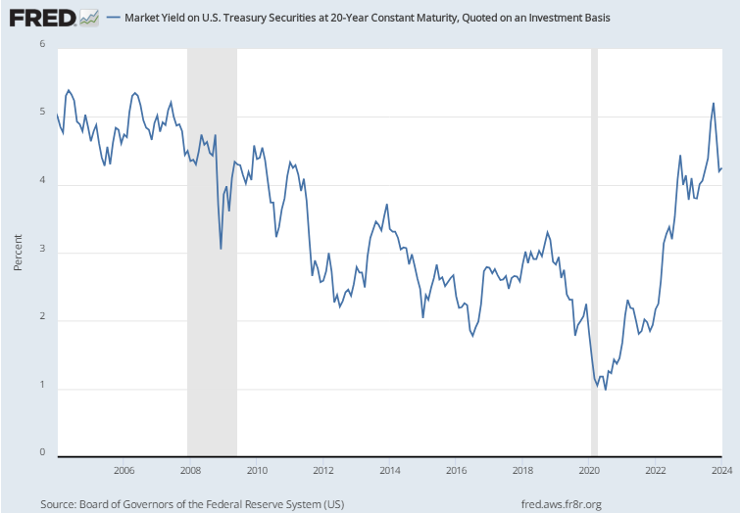

Equity Risk Premium
The equity risk premium (ERP) is defined as the additional premium over and above a risk-free rate that an investor requires to entice him or her to invest in a stock rather than a bond.
Unlike the risk-free rate, the ERP cannot be observed or determined directly, as a result many different methodologies are used to estimate the ERP. Despite often being referred to as “one of the great mysteries of finance”, selecting and applying an appropriate ERP in the income approach to valuation is fundamental to the determination of market value.
The current methods for estimating the ERP can generally be classified into three categories: historical (backward looking), implied (forward looking), and surveys (prevailing opinion).
Dr. Damodaran provides a cautionary note regarding reliance on looking back:
“The allure of having the historical data that we do in financial markets, especially in the United States, is that there is information in the past. The danger of poring over this historical data is that a focus on the past can blind us to structural changes in markets that can make the future very different from the past. To get a measure of what equity markets are offering in terms of expected returns, we are better served with a forward-looking and dynamic measure of these returns.”
In the chart below, Dr. Damodaran provides an example of the degree of change in his estimate of the forward-looking implied equity risk premium over the last 60 years: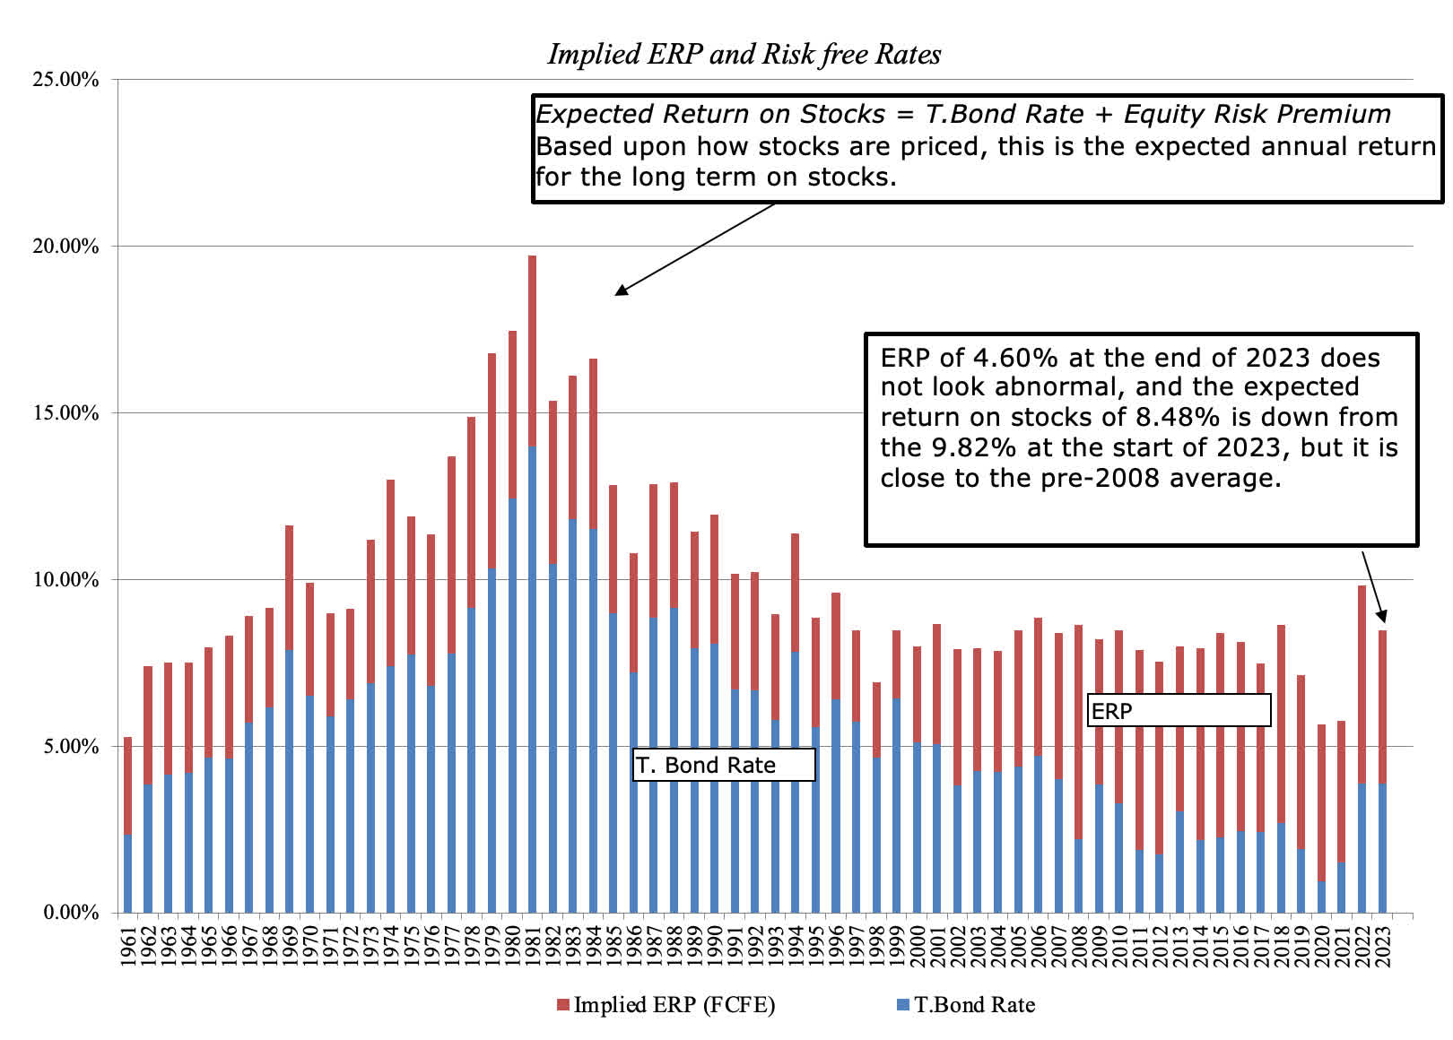
In our 2024 studies we looked at several publicly available, independent estimates of the equity risk premium. The following are a sample of some of the most current estimates identified by staff:
BVR – CSRP Historical ERP 20-Year Treasury Bond (1928-2023) 6.45%
S&P Global Market Intelligence (January 2024) 5.00%
Damodaran Implied ERP Trailing 12 Month Cash Yield (January 2024) 4.60%
Damodaran Implied ERP – Normalized Earnings & Payout (January 2024) 4.29%
Damodaran Implied ERP Trailing 12 Month with Adjusted Payout (January 2024) 4.57%
BVR Dr. Damodaran Implied ERP (2023) 6.37%
Damodaran Implied ERP Net Cash Yield (2024) 4.43%
After considering all available ERP estimates, we selected 6.20%, as our base ERP estimate for use in the CAPM model this year.
Beta
Beta (β) is a measure of volatility, or systematic risk. This component reflects how risky an asset is compared to overall market risk – it is a function of the volatility of an asset and the market. By definition, an average risk company has a beta of 1.0 relative to the market. An asset with a beta of .50, therefore, has half as much systematic risk as an average asset; an asset with a beta of 2.0 has twice as much.
Value Line Investment Survey calculates an estimate of Beta for each of the selected guideline companies. The Beta estimates used in our studies are directly from Value Line.
DIVIDEND GROWTH MODEL (DGM)
A Dividend Growth Model, or commonly known by its acronym, DGM is a financial equity valuation model based on the Gordon Growth Model developed by financial economist Myron Gordon, PhD in 1956. Other names for this model include the Dividend Discount Model (DDM) and the Discounted Cash Flow model (DCF), but regardless of the name, these variants represent different mathematical forms of the same equity model.
This equity model states that the cost of the equity component is equivalent to the current dividend yield plus the expected growth rate of these same dividends. The model we employ is commonly expressed in the following form:
K_{e} = (D₁/P₀) + G
Where: | K_{e} | = Cost of Equity
 | D₁ | = Expected dividend per share
 | P₀ | = Price per share
 | D₁/P₀ | = Expected dividend yield

Expected Dividend Yield (D₁/P₀)
The dividend yield component of the model, D/P is relatively straightforward and simple to calculate. We compile the expected dividend per share listed for each guideline company in the Value Line reports and divide it by the listed price per share as of December 31st. We evaluate the resulting yields to determine the typical dividend yield for the industry.
Growth Estimate (G)
The application of the growth component has traditionally been the subject of some interpretation. This arises from the subjective nature of estimating a perpetual steady-state growth in dividends that the model requires.

Dr. Damodaran advises the following:
“This growth rate [in the Gordon growth model] has to be less than or equal to the growth rate of the economy in which the firm operates. No firm, no matter how well run, can be assumed to grow forever at a rate that exceeds the growth rate of the economy.”
Additionally, the CFA Institute states:
“The Gordon growth model form of the DDM [single stage DDM] is most appropriate for companies with earnings expected to grow at a rate comparable to, or lower than the economy’s nominal growth rate. Businesses growing at much higher rates than the economy often grow at lower rates in maturity, and the horizon in using the Gordon growth model is the entire future stream of dividends.”
When applying the DGM model in our Idaho yield rate studies, we use a combination of a near-term growth estimate combined with a long-term estimate to account for the expectation of a going concern operating indefinitely.
Near-term Growth
The near-term growth factor in our model is derived from Value Line analysts’ 3-5 year estimates of expected dividend, earnings, and cash flow growth for each guideline company. Consequently, the average near-term growth rate is different for each industry.
Long-term Growth
We use projected nominal GDP growth of the US economy as a proxy for long-term growth. This rate includes both a real GDP growth factor and an inflation component. We view this as a conservative estimate for the reasons stated above by Dr. Damodaran.
The long-term growth rate applied in all of our multi-stage DGM models this year was calculated to be 4.28%.
RECONCILING THE EQUITY MODELS
There is no specific formula or process for reconciling the estimates of the market cost of equity derived from the CAPM and DGM models. This process does not involve a simple averaging of the different estimates but does require careful consideration of which model would be most appropriate to estimate the cost of equity for a given industry. It should also be consistent with the capitalization technique selected using informed judgement.
BAND OF INVESTMENT
As the final step in developing the weighted average cost of capital (WACC) for a subject industry, staff appraisers use what is known as the band of investment technique. This technique involves stratifying the selected market cost of debt and market cost of equity into bands of investment and weighing each proportionally based on the optimal capital structure employed in the subject industry.
The Band of Investment technique is shown in the example below:
Capital Components |  | Capital Structure |  | Market Cost |  | Weighted Rate
Debt |  | 40% | x | 5.0% | = | 2.0%
Equity |  | 60% | x | 9.0% | = | 5.4%
Weighted Average Cost of Capital (WACC) |  |  |  |  | = | 7.4%
The WACC displayed is a pre-tax estimate for example purposes only and does not represent any specific industry.
Dividing the income of a company by the WACC provides an indication of value and represents a price that can be paid for the property that would result in an income stream sufficient to satisfy the lender of debt and the investor in equity. Dr. Damodaran provides additional insight into the nature of WACC:
“[T]he cost of capital in a valuation is not a return that you would like to make on the company that you are valuing and it is not a receptacle for your hopes and fears, where you respond to discomfort with uncertainty by increasing your discount rate. It should not be, though it often is, a mechanism for reverse engineering a pre-determined value.”
OTHER CONSIDERATIONS
Normalizing the Risk-Free Rate
Staff, as well as most other valuation practitioners believe that the use of a normalized risk-free rate contradicts valuation theory. When you select a rate that is different from what is available and visible in the market, you are inappropriately introducing risk into what should be a risk-free rate. In financial markets, risk is often thought of as uncertainty in an expected rate of return. By changing the risk-free rate from what it is to what you think it should be you are incorporating additional uncertainty. The only thing that is visible, certain, and risk-free is the rate of return that is actually available to the investor.

Furthermore, when we calculate the cost of capital, we are determining an opportunity cost. We are looking for the minimum required rate of return that an investor will demand given competing investments with commensurate risks in the market. One of those competing investments is a risk-free return that can be derived from the purchase of a government backed Treasury bond. When we assume a risk-free rate in the model that is not available to the investor for purchase, we are contradicting the principle of an “opportunity cost”.

Dr. Damodaran states it this way:

“The risk free rate is not just a number in a discount rate computation but an opportunity cost. One way to think about the risk free rate is that it is the rate you will earn if you choose not to take the risky investments that are out there (stocks, corporate bonds, real estate, a business venture). So, let's carry this to its logical extreme. Let's assume that you do replace today's risk free rate (2% or lower) with your normalized rate (4%) and that the resulting high discount rate gives you a low value for your risky asset. Let's then assume that you choose not to invest in that risky asset. Where do you plan to invest that money instead? In your normalized bond earning 4%? Since it exists only on your spreadsheet, I am afraid that you will have to settle for that "abnormally" low 2% interest rate.”

Appraisal staff will continue to use our current method of determining an appropriate risk-free rate by using an average of the 20-year Treasury bond yields reported in the final quarter of the current year by the Federal Reserve Bank.

Flotation Costs
Flotation costs occur when new issues of debt and equity securities are sold in the financial market, with the issuing firm incurring costs such as accounting fees, legal expenses, and preparation costs. These costs are a normal cost of doing business that reduce the proceeds received by the issuing firm much like underwriter fees and points that occurs when obtaining a mortgage.
Richard Simonds, PhD, points out in the Journal of Property Tax Assessment & Administration:
“When capitalizing net operating income in the income approach, a flotation-cost adjustment cannot be applied to the cost of capital. Advocates of an adjustment may be confusing the concept of the allowed rate of return on invested capital in a rate-regulated environment with the concept of the market-determined opportunity cost of capital.”

Furthermore, flotation costs that are included in the discount or capitalization rate will in effect treat reinvested dollars and capital raised through preemptive rights of existing stockholders as if having flotation costs when in fact no such costs exist. The result of including flotation costs in the discount rate would contribute to understating the income approach indicator of value.
A concern often debated is how these costs should be acknowledged when valuing a property. We generally adhere to the recommendation stated below:
“[A]djusting for flotation costs in the rate of return is erroneous because it implicitly adjusts the opportunity cost of funds supplied to the firm. The true market-determined opportunity cost is unaffected by the flotation costs of a particular firm. The correct procedure for the economic analysis of flotation costs does not alter the weighted average cost of capital.”
In other words, flotation costs represent a negative cash flow and can be accounted for as such, if they are a part of the normal outflow of cash for a given company.

Market Cost of Equity vs. Allowed Return on Equity
The allowed rate of return is a form of price setting decided by governing bodies that regulate rates and services of public utilities. Its determination is often influenced by elected and appointed officials, politics, environmental considerations, and negotiated settlements. Investor-owned utilities operate as natural monopolies, and the allowed rate of return is used as a substitute for the effects of a competitive market on shareholder returns and rate-payer prices. The job of the regulator is to attempt to strike a balance between the interests of several stakeholders.
The differing objectives and principles behind the calculation of the market cost of equity and the allowed rate of return are what set them apart from one another. The allowed return on equity is an often-negotiated benchmark for a fair rate of return on investment for a utility; while the market cost of equity is the minimum return on equity required by a shareholder looking to invest in a firm with similar risk. In his text, The Economics of Regulation, Alfred Kahn argues that the cost of equity is the starting point, not the end goal, in setting the rate of return. Kahn also suggests that regulatory policies should create incentives for utilities to innovate, which aligns well with the regulatory goal of balancing shareholder and ratepayer interests.
“Many in the regulatory community believe that the utility’s rate of return is the sole value driver, and that rates of return are set at the cost of equity. Neither of these perceptions is correct. Instead, the financial “value engine”—the difference between a utility’s return on investment and its cost of capital—drives shareholder returns.”
The relationship between allowed rates of return and rates used in valuation has been addressed in courts across the U.S. As recently as 2020, Utah Second District Court, had this to say:
“Authorized returns on equity are neither correlated to nor determinative of the calculation of the cost of equity for valuation purposes. The cost-of-equity rates calculated in rate cases serve the regulatory purpose of setting rates but are not appropriate to establish value in a long-term perpetuity cash flow model.”
Utility industry economist Leonard Hyman puts it most succinctly below:
“The market determines the cost of capital. Regulators don’t.”²⁰
The Idaho State Tax Commission, Property Tax Division, agrees that the regulatory allowed return on equity is not an appropriate substitute for the calculation and analysis of a market derived cost of equity used in valuation.
As promulgated by Idaho Code and Administrative Rule, we will continue to use nationally recognized methodologies and models to calculate the market cost of equity and ultimately the WACC applicable in the income approach.

OPERATING PROPERTY BUREAU APPRAISAL STAFF
Jerott Rudd, Bureau Chief – Water Transportation
Jerott.Rudd@tax.idaho.gov | 208-334-7723
Dave Weddle – Staff Support, Gross Earnings Tax
Dave.Weddell@tax.idaho.gov | 208-334-7739
Jim Powell – Telecommunications
James.Powell@tax.idaho.gov | 208-334-7740
Kyle Rayworth – Non-Utility Generators, Gas Distribution, Railroads
Kyle.Rayworth@tax.idaho.gov | 208-334-7719
Erica Taggart – Investor-Owned Electrics, Gas Transmission, Railcars
Erica.Taggart@tax.idaho.gov | 208-246-8686
Tim Hurst – Water Distribution
Tim.Hurst@tax.idaho.gov | 208-334-7709
Shyanne Massie – Petroleum Pipelines
Shyanne.Massie@tax.idaho.gov | 208-334-7722

2024 SELECTED YIELD RATES BY INDUSTRY

Investor-Owned Electrics 7.74%
Railroads Class I 10.16%
Class III 11.30%
Petroleum Pipelines 10.20%
Telecommunications 9.55%
Gas Distribution 7.91%
Gas Transmission 10.08%
Water Transportation 9.57%
Water Distribution 7.23%
Non- Utility Generators
<1 mW Hydro 15.66%
1-10 mW Hydro 15.55%
>10 mW Hydro 14.30%
>10 mW Gas-Fired 13.28%
1-10 mW Digester 15.51%

See Idaho Code §63-201 (16) for a definition of operating property.
Idaho Code §63-205
Idaho Administrative Code, State Tax Commission, Property Tax Administrative Rules IDAPA 35.01.03.405.06
Western States Association of Tax Administrators, Committee on Centrally Assessed Property, Appraisal Handbook, Unit Valuation of Centrally Assessed Properties, 2009, pg. III-1
National Conference of Unit Valuation States (NCUVS) Unit Valuation Standards, revised 10/2018, Section IV. C.5(c), pg. 7
National Standards of Unitary Valuation, Unit Valuation Standards, revised 10/2018, Section IV. C.5(c)., pg.7
Brealey, Richard A. & Myers, Stewart C.et. al, Principles of Corporate Finance, 13th Edition, 2020, pg. 115
https://fred.stlouisfed.org/series/DGS20
https://aswathdamodaran.blogspot.com/2022/01/
https://seekingalpha.com/article/4663443-data-update-2024-stock-comeback-winning-expectations-game
Ross, Westerfield, Jordan, Fundamentals of Corporate Finance, 9th edition, pg. 416
Damodaran, Aswath, Investment Valuation: Tools and Techniques for Determining the Value of Any Asset, 3rd Edition, 2012, Ch 13, pg. 327
CFA Institute, Equity Asset Valuation, 3rd Edition, 2015, pg. 246
http://people.stern.nyu.edu/adamodar/pdfiles/papers/costofcapital.pdf
https://aswathdamodaran.blogspot.com/2011/09/risk-free-rates-and-value-dealing-with.html
Simonds, R., Income Capitalization, Flotation Costs, and the Cost of Capital, Journal of Property Tax Assessment & Administration, Volume 3, Issue 4, 2006
When estimating a discount rate for the rate-regulated electric industry, Idaho Code §63-205B requires a 20-basis point add-on to the WACC to account for flotation costs.
Copeland, T. & Weston, J., Financial Theory and Corporate Policy (3rd ed.), Addison-Wesley Publishing Company, pg. 534
Kahn, Alfred, The Economics of Regulation: Principles and Institutions, John Wiley & Sons (1970), p. 44
PacifiCorp, Inc. v. Utah State Tax Commission, No. 180903986 TX, pg. 8 (Utah 2nd D.C. 2020) ²⁰ Leonard Hyman & William Tilles, Don’t Cry for Utility Shareholders, America, Public Utilities Fortnightly (October 2016)

